I will attend each day, on time and ready to learn.
I will dress in the school uniform:

- School polo shirt
- School sweatshirt
- Your choice of trousers – jeans, jogging bottoms, skirt- but no leggings or ripped jeans.
- Black shoes or trainers

Uniform is only provided to new students, and is not kept in school for students to collect each day on arrival.

Students are not permitted to bring the following onto the school premises:
- Sweets
- Carbonated (fizzy drinks), energy drinks and sport drinks
- Smoking paraphernalia (papers, filters, lighters, tobacco, vapes, e-cigarettes)
- Mobile phones and electrical tablets. We will store these items for the day.
I will be asked to open bags and empty pockets to ensure that I am not in possession of items identified harmful. Staff may use magnetic searching wands on all points of entry to the school. I will be expected to engage in this process; if I don’t, I will not be permitted into the school.
I will hand over all of my belongings including my bag when requested on arrival. I will not be permitted access to these until the end of the day
If I am transported to the school by taxi, I will come straight onsite on arrival.
If I refuse to comply with these expectations, I will not be permitted on site and could be suspended.

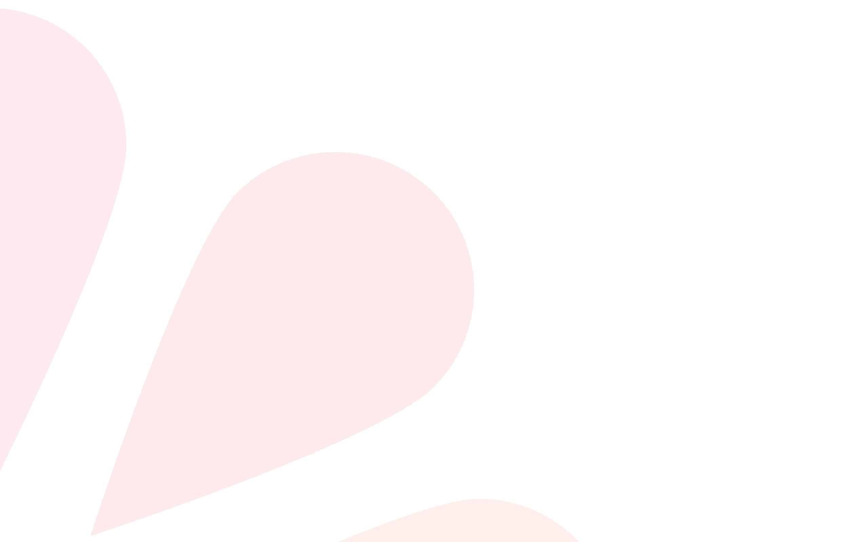
During school hours expectations:
I will follow the school expectations:
- Treat people with respect and consider their safety at all times.
- Be in the right place according to my timetable.
- Make progress towards personalised targets to the best of my ability.
I will recognise the school’s values: integrity, love, availability, inclusion, compassion, safeguarding and aspiration.

If I do not follow these expectations, I may be placed on a change of provision that may involve catch up during break times or lunchtimes, meetings during or after school, catch up session after school, suspension, fixed term suspension or permanent exclusion.
Where harm has been caused I will, with staff support, engage in a restorative process to repair harm. Persistent and/or deliberate harm to our pupils, staff or school property, may result in incidents being reported to the Police.
Violence, threats of violence, or personal verbal abuse to any Brunel community member, harms all of us and will not be acceptable.
I understand that staff will act to prevent harm. I will not stop them executing their duty of care. This may involve working away from site, exclusion or physical intervention if required to prevent harm. Staff are trained to use Physical Intervention to ensure that the school is a safe environment; if my actions threaten the safety of others or could result in injury, I may experience physical intervention to help keep me, other people, and the environment safe.
Food is provided at the school, and takes into consideration my needs, healthy eating, and provides the opportunity to socialise. I will be respectful of this, or may lose some of my lunchtime privileges to make sure the school is safe for everyone
I understand that students are not allowed off site during the school day. If I leave the site without permission (abscond) we will follow policy to inform parents/carers and the Police where necessary.
If I am displaying harmful behaviour as a result of suspected drugs or alcohol use,
I will be suspended and the Police will be contacted.
Brunel school is a smoke-free site. I will not smoke/vape on the school site.

CCTV
A Closed Circuit Television System (CCTV) is installed at Brunel School.
For further information please email: admin@brunelschool.org

